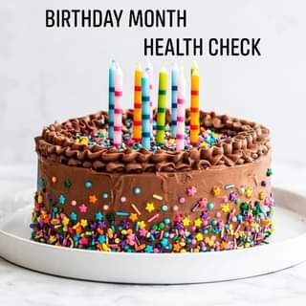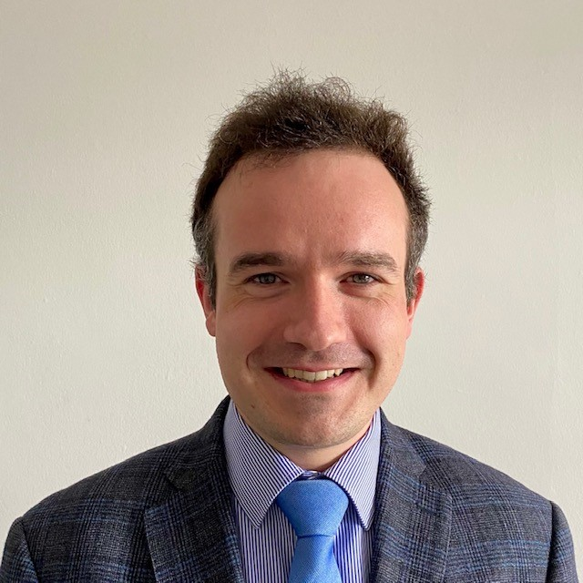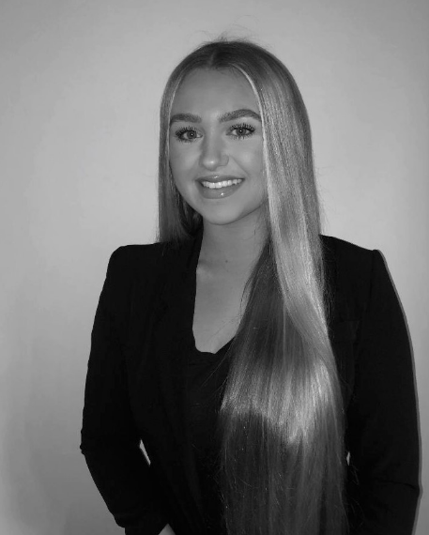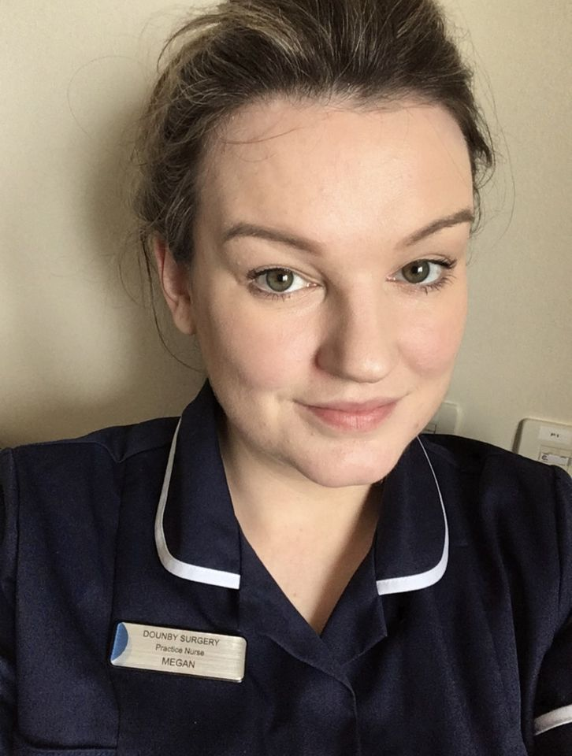

**2021**

Our Patient Service Coordinators are the first people that patients come into contact with, and they are crucial to how we work.

They are all trained to ask questions and to signpost patients to the most appropriate service or clinician. This is to ensure that our patients receive the right care from the most appropriate health professional, which may be a clinician other than a Doctor, for example a Pharmacist, Nurse Practitioner or First Contact Physiotherapist.

We understand that your health concerns are private, but if you are able to help us with as much information as possible, this will help us to make the best use of the appointments we have available.

All our Patient Service Coordinators treat patient concerns with respect and discretion and are bound by the rules of confidentiality as our clinical staff.

We are delighted to be able to invite you back in for annual health checks.

If you have an existing long-term condition, such as diabetes or asthma, during your birthday month we will invite you for your annual review ‘MOT. Depending on your condition this may simply be a telephone or online review, or you may be invited to attend the surgery.

**Reception hours:**

Monday to Friday

08:30 – 17:45

Please call us on 771209, do not come into the surgery.

We are happy to help on the phone.

**Telephone Numbers**

Dounby Surgery 771209

Prescription line 771886

Community Nurses 771540

Health Visitor 771150

**Website** www.dounbysurgery.co.uk

Welcome to our newsletter!

It is a joy to see the newsletter on the go again following interruption through these past 18 months of challenging times.  I am very proud of how strongly the practice team have pulled together, working with care and commitment to keep the surgery running effectively while protecting our community.

It has not been simple to find that balance and we are incredibly thankful to you all for continuing to work with us patiently and with understanding as we try to keep services running as smoothly as possible for all.

I admit I was a little daunted entering the unknowns of “Covid Working” when I returned from maternity leave in April, however, I was also excited at taking up my new role as GP Partner. I welcomed the offer of partnership as an opportunity to consolidate my commitment to the practice where I have enjoyed working since 2018. I hope that in coming months and years I can further invest my energy, ideas, and enthusiasm in working with the team to provide the best care we can.

As we begin to get into our stride with this new way of working, it's nice to take this moment to reflect on the year or so past and share updates on our plans for the year ahead. Remember you can also keep an eye on our website and Facebook page for regular updates. - Dr Rebekah Palmer

# Patient Service Coordinators

Dounby Surgery News



# Birthday Month Health Checks

Congratulations to our Practice Nurse, Megan, who has successfully completed a Non-Medical Prescribing course with the University of the Highlands and Islands. This will allow Megan to issue prescriptions safely and competently within the context of her professional role.

We would like to wish Megan a further Congratulations on the arrival of her second baby Mack!

Ron comes to us from placements in Dumfries and Inverness. He will be based in the surgery over the next 10 months consulting with our patients. You may bump into him at some clinics within The Balfour as well. His aim for this placement is to visit all the outer isles and learn a few Orcadian songs and tunes whilst he is here.

Lana has started her 3rd year of her 4year graduate medical course. Like Ron, she will be based in the surgery but will also be in A&E and the wards in The Balfour. So far during her medical degree, she has spent time in Fife, Highlands & Dumfries. She is excited to be further North.

She is in her 3rd week and is really enjoying her time at the surgery as well as exploring Orkney. She loves going to the beach for a swim and she is looking forward to seeing as much of Orkney as she can during her time here.

**Introducing our new ScotGEM Medical Students, Ron MacDonald & Lana Stevenson**

**Congratulations to our Practice Nurse, Megan**

# Updated Covid restrictions in healthcare

As we are sure you are all aware, Scotland has moved to beyond level 0 at the start of August, which has meant a significant change in many of the restrictions we’ve all been used to.

However, the Scottish Government have previously asked that we maintain a higher level of protection in order to safeguard all of the patients visiting the surgery, some of whom are particularly vulnerable, and this guidance has not yet changed.

A facemask mill still be required when attending the surgery and the 2 metre distancing rule will remain.

Until these measures can safely be removed, we will continue to do everything we can to keep our patients and staff as safe as possible.

Thank you for your continued support, we appreciate your kindness and understanding during what is a difficult time for everybody.

**Welcoming our new Practice Nurse, Helen Clouston**

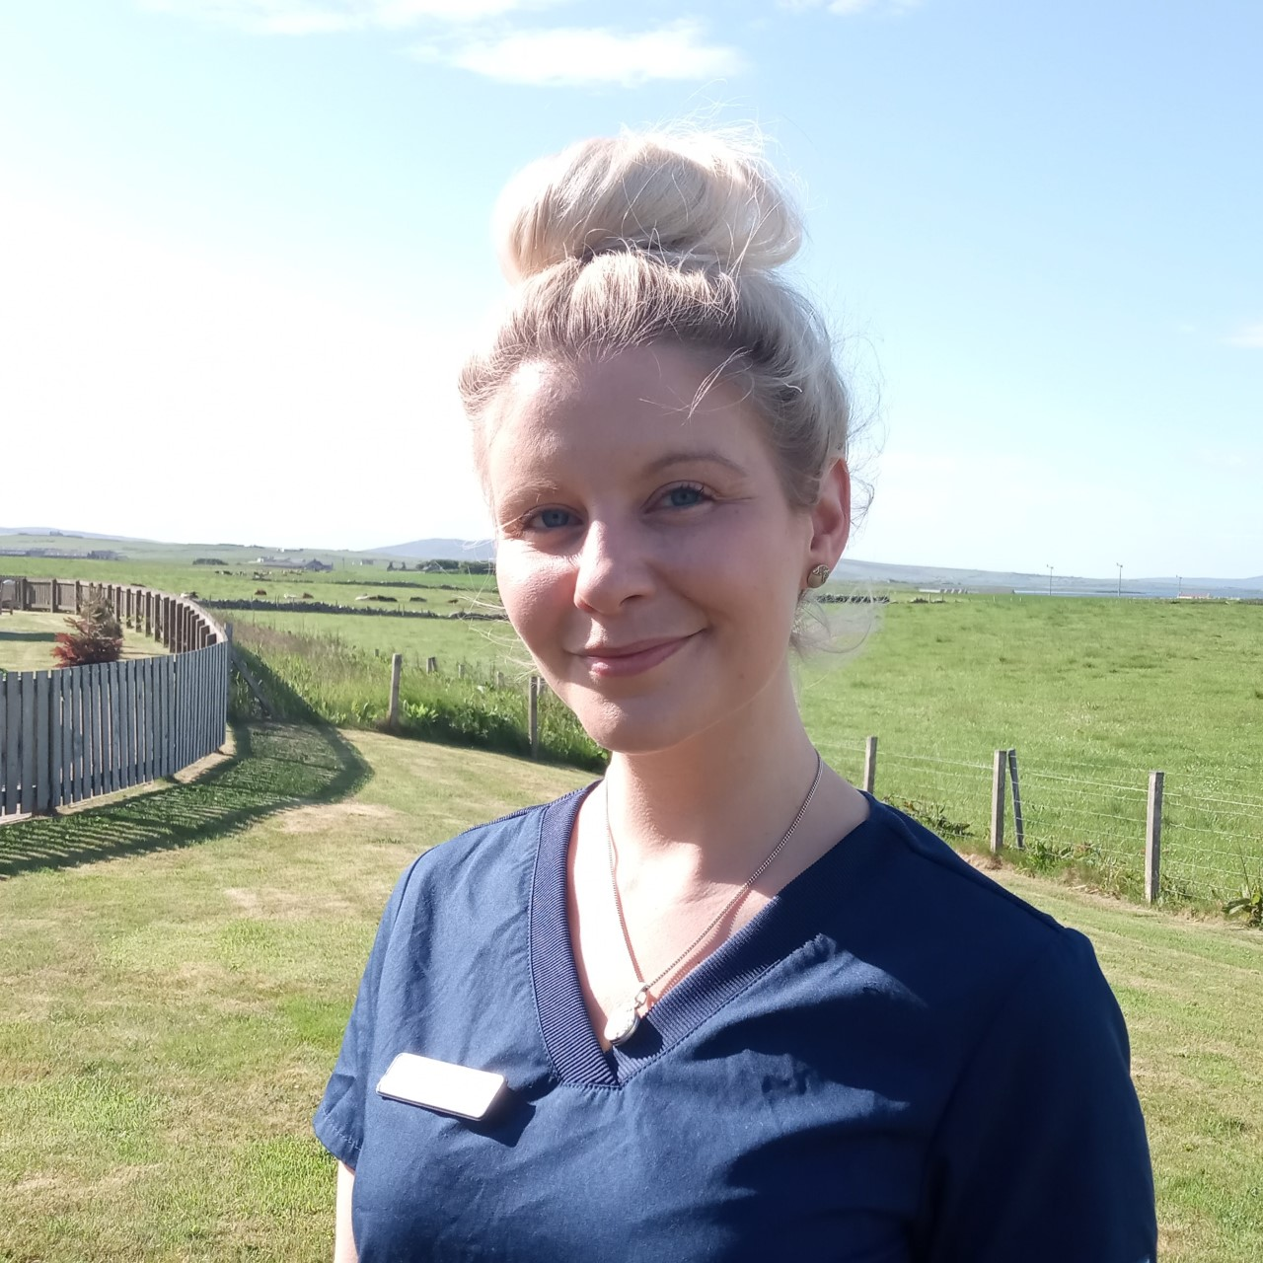

We are delighted to welcome Helen to our Nursing Team here at Dounby Surgery. Helen joined Dounby Surgery in February this year. She qualified in 2008 and since has worked in the Macmillan Unit, Primary Care, and latterly with the East and West District Nursing Teams.

Helen has special interests in wound care, bladder dysfunction and Nursing research and education. She is looking forward to developing her skills in women’s health and chronic disease management.

Welcome to the team Helen!

**Ordering Repeat Prescriptions**

You can order your repeat prescriptions several ways:

* Our Website
* Post your Tick box sheet in the letterbox beside the front door.
* Our dedicated Hotline 01856 771 886

Please remember that we are unable to process repeat prescriptions through our normal phone number. This number is for clinical queries and appointments.

**First Contact Physiotherapist**

We would like to welcome Graham Boniface to our team as our First Contact Physiotherapist.

Graham will be able to assist you with bone, joint or muscle pain. He will be able to assess you, diagnose what is happening, give an expert advice and refer you to a specialist service is necessary.

Please telephone reception to arrange an appointment.

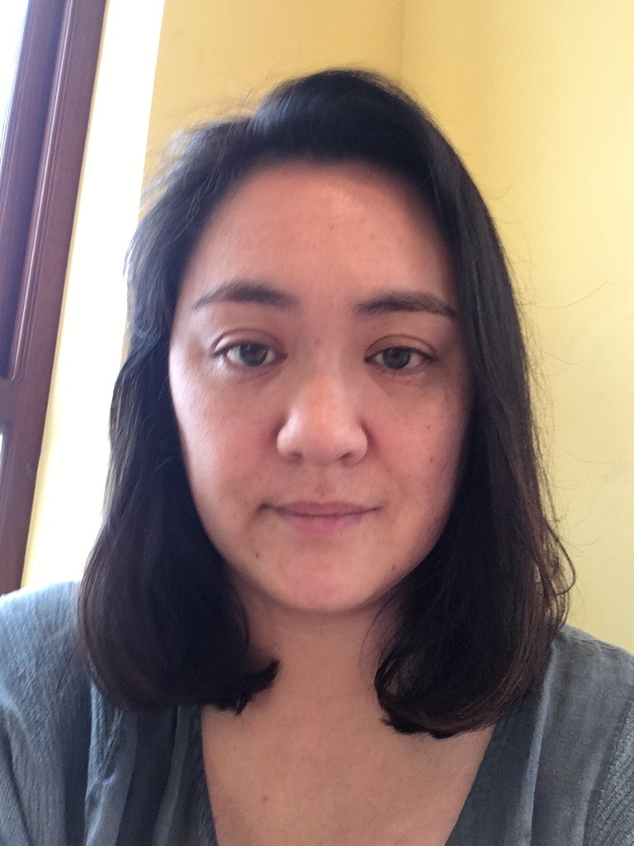

**Congratulations Dr Shen Gills**

Dr Gills has passed all her Royal College of General Practitioners exams and is now a fully qualified GP. Dr Gills has worked at the surgery throughout her training and is a great asset to the team.

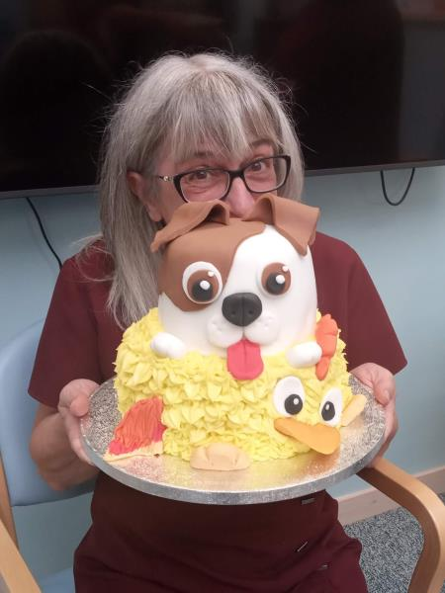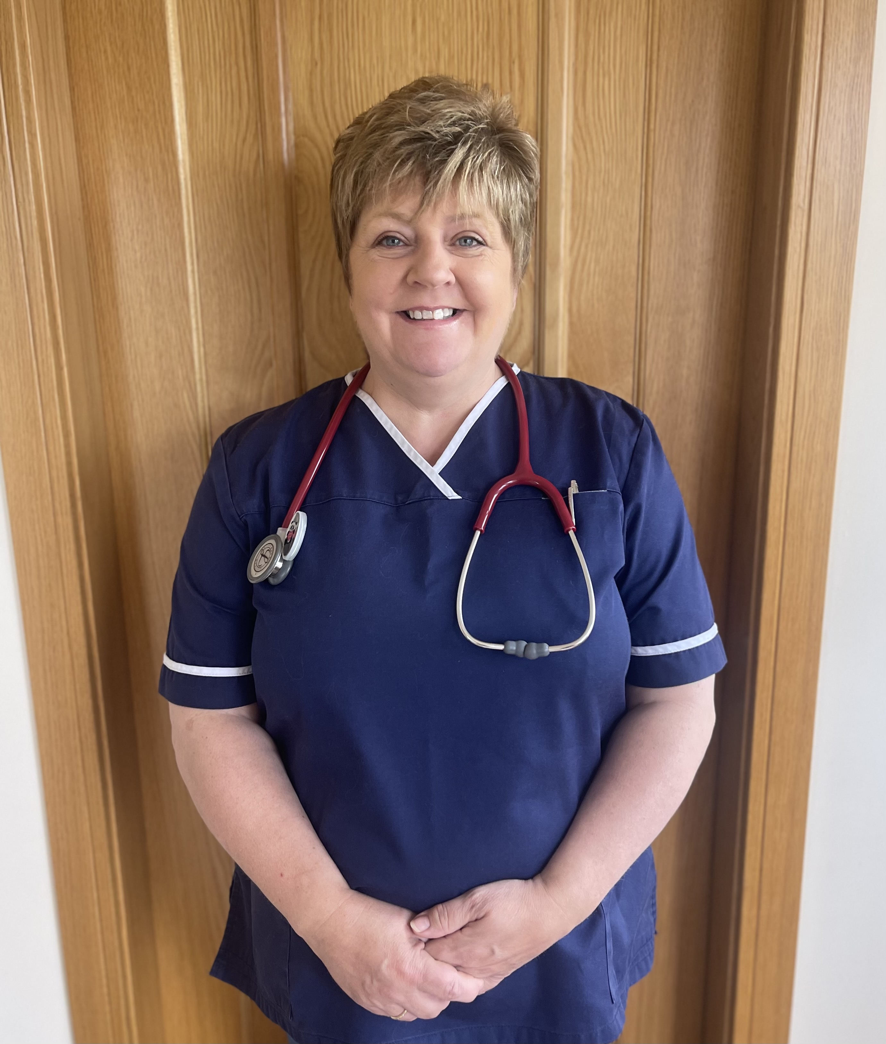

Vaccinations for our youngest patients will now be done within the surgery by NHS Orkney’s dedication vaccination team. They will be in the Practice on Friday mornings. 6 week baby checks will be carried out by our GPs.

**Changes to Childhood Vaccinations**

Introducing Yvonne to our Admin team!

Yvonne joined us in June as one of our Patient Service Coordinators and has been a great asset to the Admin team already. She has been quick to learn the ropes and is always a bright voice on the end of the phone.

Yvonne relocated to Orkney to be closer to her Orcadian relatives. She is interested in WW1 Nurse history & genealogy. She has enjoyed being part of our friendly team and looks forward to meeting more of the local community.

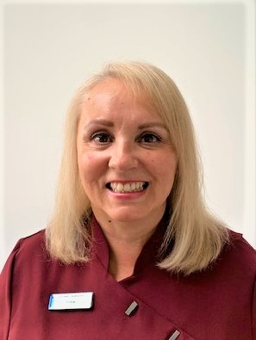

Saying goodbye after 14 years, I am leaving to embark on the next chapter. I have been very lucky to be blessed with grandchildren and will be taking an active role in looking after them.

I qualified as an Enrolled nurse in 1986 at the Orkney School of Nursing with the fabulous Lorraine Littlejohn as my tutor. No nonsense hands on training with icons such as Nanna Hourston and Joyce Mudd at the helm. Doctors such as Bob Hazlehurst, Peter Fay and Jim Cromarty were a formidable sight in any ward. Following further training in 2005 I graduated to Staff Nurse working in Piper ward. This was a fabulous job, working in rehab to get patients well and home. It was while working there that the opportunity came to apply for a job in Dounby Surgery. I had been working at the health centre at the then Scapa Practice doing bloods and treatment room stuff now and then. This was a very different form of nursing found me training further to learn about chronic disease management, prescription medication, acute illness, smear taking, asthma - the list goes on. I could see the role of the nurse and the doctor start to blend together so that patients and their families would see a more holistic approach to their care.

**Welcome to the Admin team Yvonne Clay**

To say I have enjoyed this job would be an understatement. I have absolutely loved my time in Dounby and have worked with some amazing people over the years - people who have supported my journey and encouraged me to achieve many things including one of my highlights. A trip to the phototherapy dept at Ninewells Hospital in Dundee gave me the ability to offer and deliver a phototherapy service to the people of Orkney. Supported by Dr Huw Thomas and the team in Dundee, phototherapy has been life changing to some of the people who used the service.

I would like to say good luck to Helen and the nursing team and send a heartfelt thank you to those wonderful people at Dounby surgery past and present, to my fantastic colleague and friend Michelle Hill and of course most of all to all you lovely patients who have coloured my 14 years and have made my job so rewarding. Although I’m leaving my permanent role you might see me pop in from time to time. Karen Leask

**Sue’s Retirement**

It was a sad day as Sue retired after almost 17 years at Dounby Surgery.  
Sue had a background as a Medical Secretary and brought a great deal of knowledge to the team in Dounby. We will greatly miss her guidance, medical note summarising and data quality skills along with her cheeky sense of humour, guaranteed to brighten up our surgery.  
We wish Sue many happy years in her retirement.

**Farewell Nurse Karen Leask**